**Feedback for MODULE**

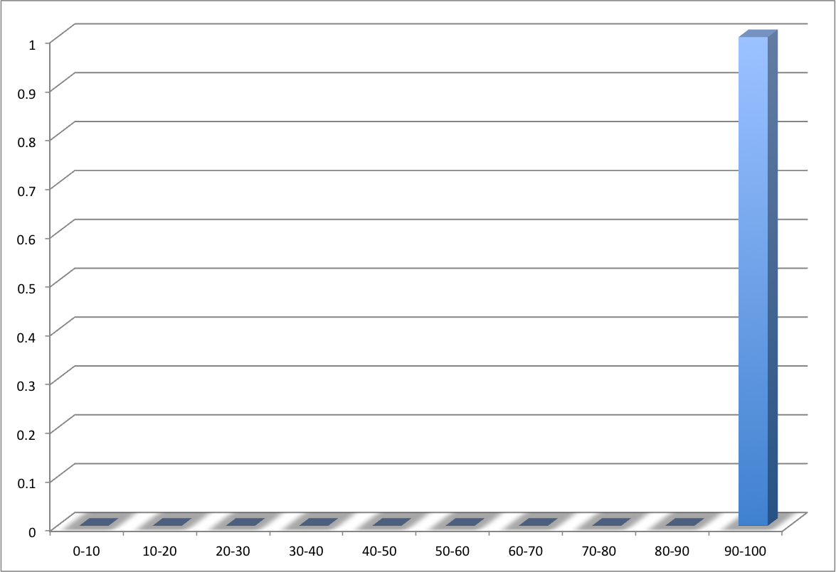

|  |  |  |
| --- | --- | --- |
|  |  |  |
| Details | Student ID | B00123456 |
| Name | Joe Bloggs |
| Email Address | Bloggs-j3@email.ulster.ac.uk |
| Modules |  | |
|  | |
|  |  |
|  |  | Marks |
| Data Analysis | **Criteria 1** | 30 |
| **Criteria 2** | 30 |
| **Criteria 3** | 40 |
|  |  |
| **Total** | **100** |
|  | Comment:  Here is an example of the paragraph.  With a new paragraph. | |